Dan Collins, Principal Investigator
SCAPE / ASU Project #BTS0406
Arizona State University
PO Box 871505
Tempe, AZ 85287-6011

Phone: 480-206-2037
Email: dan.collins@asu.edu

Nov. 8, 2017

Karen Scott
Senior Environmental Education Specialist
US EPA
Office of External Affairs & Environmental Education
1200 Pennsylvania Ave., NW, 1426D
Washington, DC 20460

Phone: 202-564-2194
Email: Scott.Karen@epa.gov

RE: Quarterly Report #5 (July 1, 2017 – September 30, 2017)

Grant Number (FAIN): 83659001
Title: SCAPE (Sustainable Communities and Place-based Education)
Budget Period: 06/01/2016 – 5/31/2018

Dear Karen: This fifth quarterly report reflects SCAPE EE curriculum development activities, project management, and documentation over the months of July, August, and September of 2017. There are also photos taken during recent trip on November 1, 2017 to Cedaredge School in Southwestern Colorado, a new link to edited videos, and a recently released report on “pre-interviews” conducted by the University Office of Evaluation and Educational Effectiveness (UOEEE) at ASU. The next report is due at the end of December 2017.

It would be helpful to know if there is any possibility for extending the grant another year—through May of 2019. This would include the same list of partner schools. Of course, the program could be run for a fraction of the cost. We would need funds for the following: stipends for 10 teachers, SCAPE core team research/evaluation, documentation, publication/exhibition, regional workshops, travel. A projected total cost to continue the program for the 2018-2019 academic year would be $50K.

Quarterly Report (July 1 – September 30, 2017)

This Report focuses on our most recent quarter (July 1 – September 30, 2017). The core team and SCAPE teachers negotiated the challenges of translating the information garnered from the summer workshop in June to the actual introduction of the curriculum to students in our schools across the Colorado River Basin. Further work has been done to ensure continuity of lessons and clarity of navigation. Refinements regarding Assessment and Standards are ongoing. A hyperlinked glossary now runs to some 39 pages. One-on-one phone interviews were organized and conducted by SCAPE ASU evaluator, Matthew Gallagher. Matthew also created a very useful spreadsheet of teacher responses to the first online Quarterly Survey he and Collins developed. A final report by Matthew on his initial interviews with SCAPE teachers can be found at: http://www.coloradoriverscape.org/uploads/2/0/1/2/20120621/scape_preinterviewreport_2017_final.pdf

Our first “all SCAPE” conference call was conducted by Dan Collins on Oct. 20 followed by individual communication via phone or email with most of the teachers.

The group conference call via Skype included Dan Collins (SCAPE PI), Shaun Ylatupa-McWhorter (Computer Database Specialist from ASU), Monica Elser (Head of Sustainability Education, Flathead Lake Bio Station, University of Montana), Dr. Elena Ortiz (Science professor, Phoenix College), Deb Noble (Science teacher, Pinedale, WY), Chris Bires (Science teacher, Boulder City, NV), Kevin Dunbar (Science teacher, Cedaredge, CO), Rex Lybrand (Science teacher, Telluride, CO), and Mary Walker-IrvinI (Science teacher, Grand County HS, Moab). Follow up phone calls and individual Skype calls were conducted by Collins with Kristen McClellan (Science teacher, Grand Junction, CO), Jesus Cordova (PPEP High School, San Luis, AZ), and Steve Smith (Animas HS, Durango, CO).

As indicated in previous Quarterly Reports, the full curriculum should now be accessed on Google Drive (this is the new “coloradoriverscape.org address). The most convenient place to start is with the Table of Contents, which provides links to the entire curriculum (use control + click on link below. Once the document opens, make sure you are in the “Viewing” side of the Google .doc application and not the “Editing” side):
https://docs.google.com/document/d/1vfBwsVr0WFMAkjCPyyMm4f33P5muKNdLjOXUZKi0hgE/edit?usp=sharing

Since the last report (July 17, 2017), the core team continues to generate original content and invaluable feedback/work on the curriculum as a whole. A trip to Cedaredge High School was made by Collins and Phelps (Kevin Dunbar, Science teacher) on November 1. More detailed Assessment Tools and Standards are being developed for each Lesson. I am working my way through the curriculum (again!) making very fine-grained edits, ensuring that sources are properly credited, inserted new images, adding detailed Assessment Rubrics to each Lesson, and expanding the Resources, References and Glossary sections.

Documentation

Kaard Bombe, our project videographer and photographer, continues to contribute wonderfully engaging video and still images to the project. A final cut of the two videos he produced on SCAPE curriculum at the Orme School are now publically available on Vimeo here: https://vimeo.com/coloradoriverscape. I too am adding footage to the project. I have included stills from the field trip to Cedaredge High School. See Addendum A below.

The final report in June 2018 will feature a video overview that not only captures the work being done on site with our partner schools, but vignettes of team members reflecting on the successes—and failures—of the SCAPE project.

SCAPE Partner Schools

- Animas High School, Durango, Colorado
- Boulder City High School, Boulder City, Nevada
- Cedaredge High School, Cedaredge, Colorado
- Grand County High School, Moab, Utah
- Grand Junction High School, Grand Junction, Colorado
- Maryvale High School, Phoenix, Arizona
- Pinedale High School, Wyoming
- Telluride High School, Colorado

Schools/Institions recently added this quarter as “sub-award” entities:

- PPEP Tec HS / Cesar Chavez Learning Center, San Luis, Arizona

Independently funded Schools/Institions recently added this past quarter:

- PPEP Tec High School / Jose Yepez Learning Center, Somerton, Arizona.

The two PPEP schools are both located south of Yuma, AZ and are very close to the Mexico/US border. They are adjacent to very impacted reaches of the Colorado River and have student populations that are 99% Latino.

SCAPE Website

We continue to expand on the public website for the project: http://coloradoriverscape.org The site features interactive maps, a document repository, a bibliography, links to team members and project partner schools, and all of our quarterly and annual reports to date. Two online maps—one using ArcGIS protocols, the other Google My Maps—are provided. A second “internal” website has been developed using Google Sites. This provides a secure portal for SCAPE teachers who can use it to access instructions for utilizing the curriculum, building maps, uploading data, storing student work, and creating data visualizations. It can be accessed here: https://sites.google.com/a/coloradoriverscape.org/units/home I suggest that you go through the process of requesting a @coloradoriverscape.org account so you can get a full view of how we are managing the project and implementing Cloud-based technologies with all of our partner schools.

SCAPE Budget Management

Our project “financial specialist” at ASU is Linda Guerrero who continues to keep on top of expenditures. Linda and I have been meeting regularly to discuss the financial picture.

SCAPE Evaluation

The University Office for Educational Evaluation and Effectiveness (UOEEE)—in particular, Matthew Gallagher and Alison Cook-Davis—have provided invaluable assistance. Their involvement has increased with the start of the second year of the grant. We have developed a detailed calendar for their participation and deliverables (based in the original EPA grant formative and summative targets, but with more detail). The “SCAPE Quarterly Report” developed by Matthew has been renamed “SCAPE Quarterly Survey” to distinguish it from my regular quarterly reports to the EPA. The original version is linked here: http://www.coloradoriverscape.org/info.html (If the interactive .pdf does not load, first download the document to your local drive and open within the latest version of Acrobat Reader). Matt also created a very useful spread sheet that distills teacher comments from the 1st Survey. Find it here: http://www.coloradoriverscape.org/uploads/2/0/1/2/20120621/data_extract_-_scape_quarterly_survey.xlsx

Goals for Quarter #6 (Oct. 1 – Dec. 31, 2017)

--Conduct workshop for PPEP schools in Yuma, AZ (November 20-21, 2017).
--Teachers complete 2nd SCAPE online Survey of curriculum implementation by Dec. 6, 2017.
--Organize/conduct 2nd SKYPE conference call (Dec. 15, 2017)
--Complete school visits or Skype calls as needed with individual teachers.
--Shoot/edit additional video footage for SCAPE documentation and recruitment.
--Share SCAPE curricular ideas with “Future of H2O” consortium at ASU.
--Complete Assessment protocols for each Lesson.
--Link appropriate NGSS standards to each Lesson.
--Begin to design prototype “exhibition kit” for use by partner schools in their “end of year” displays.
--Create “publication ready” version of SCAPE curriculum.
--Seek funding for supporting SCAPE for a third year in 2018/2019.

We are very proud and pleased with the progress made to date. Please advise if you need further documentation of our efforts.

Regards,

Dan

ADDENDUM A: Gallery of Images

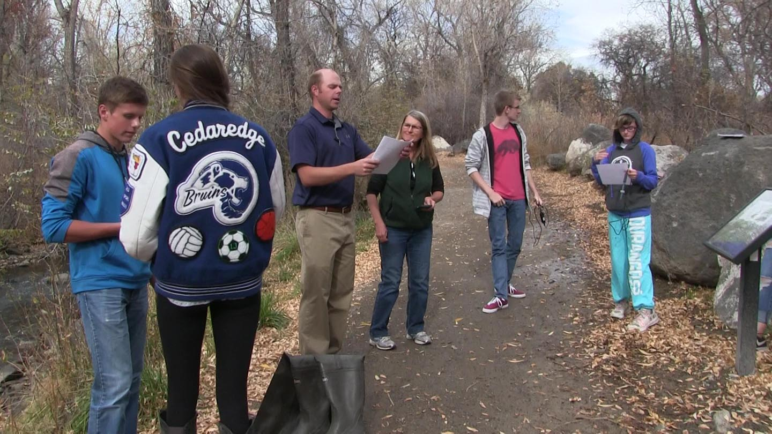
Fig. 1. Science teacher Kevin Dunbar and SCAPE water quality specialist Vicki Phelps review protocols for water sampling with Cedaredge High School students. Surface Creek, Cedaredge, Colorado. November 1, 2017.

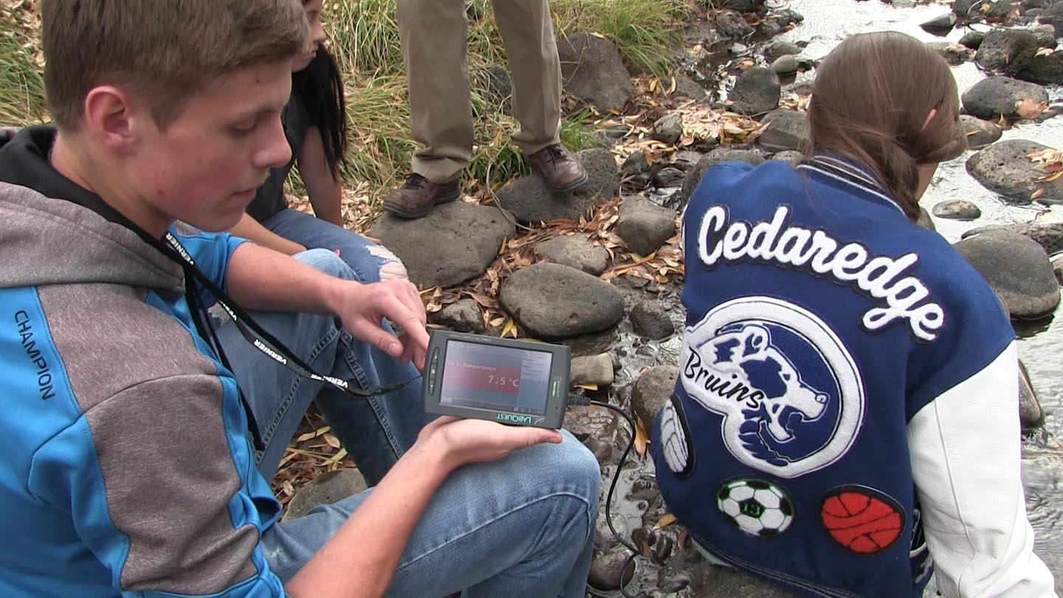
Fig. 2. Cedaredge High School students use Venier sensor to sample temperature. Surface Creek, Cedaredge, Colorado. November 1, 2017.

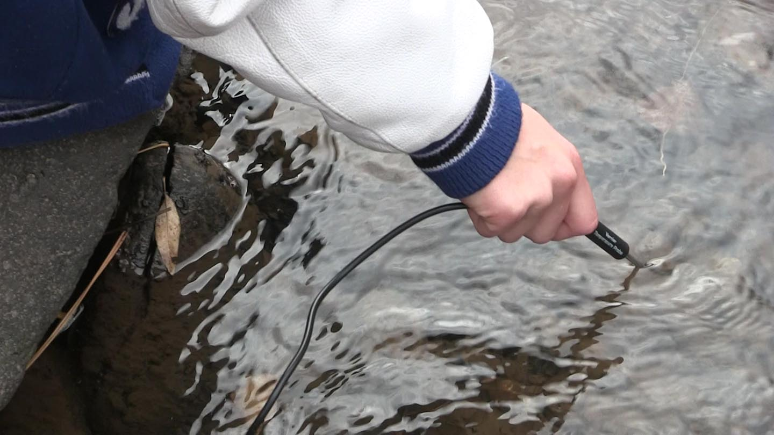
Fig. 3. Cedaredge High School students use Venier sensor to sample temperature (detail). Surface Creek, Cedaredge, Colorado. November 1, 2017.

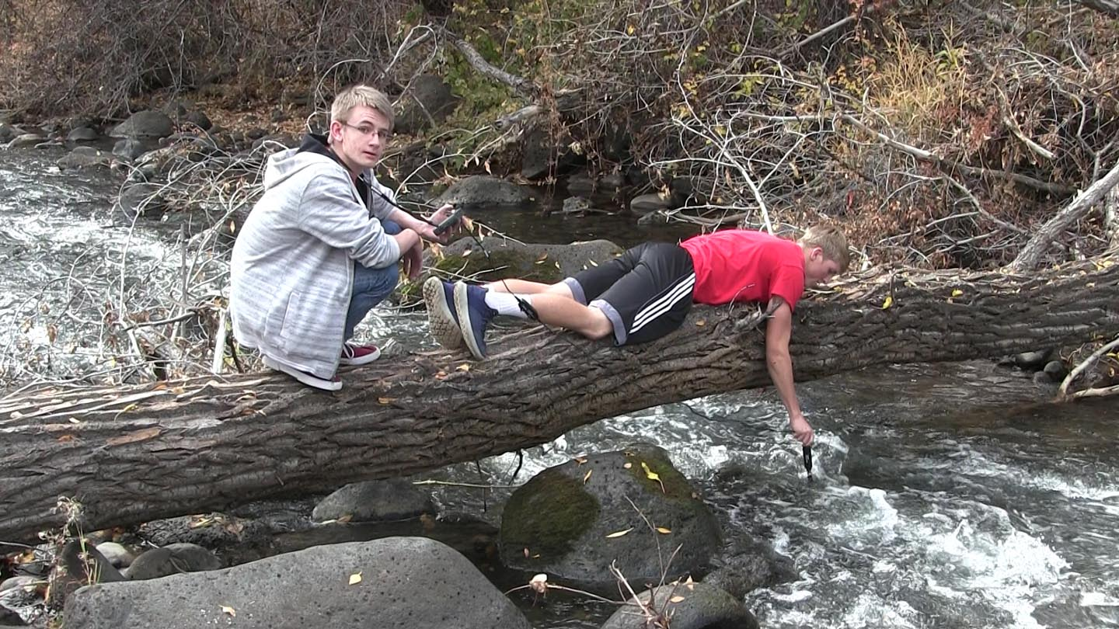
Fig. 4. Cedaredge High School students use Venier sensor to sample Dissolved Oxygen (DO). Surface Creek, Cedaredge, Colorado. November 1, 2017.

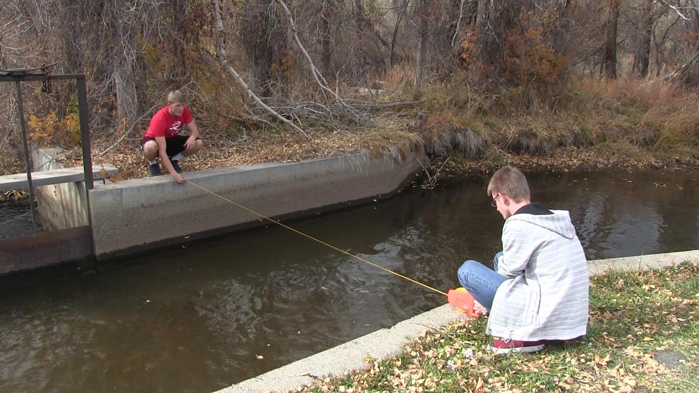
Fig. 5. Cedaredge High School students measure stream width -- one value for determining area of cross section. Surface Creek, Cedaredge, Colorado. November 1, 2017.

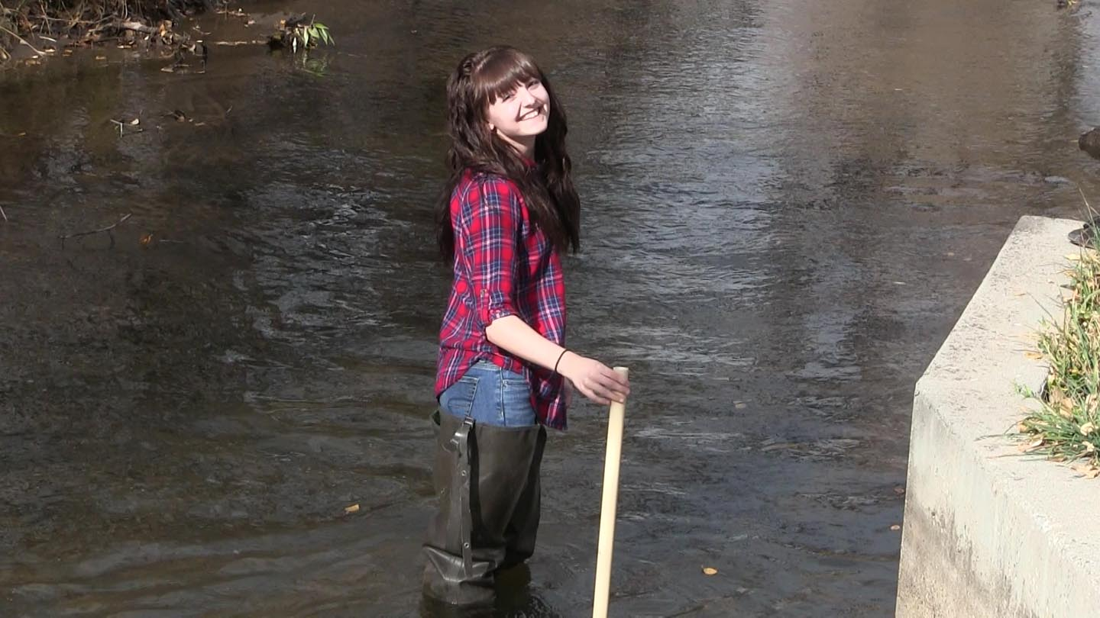
Fig. 6. Cedaredge High School student takes depth meaurements—one set of values for determining area of cross-section. Surface Creek, Cedaredge, Colorado. November 1, 2017.

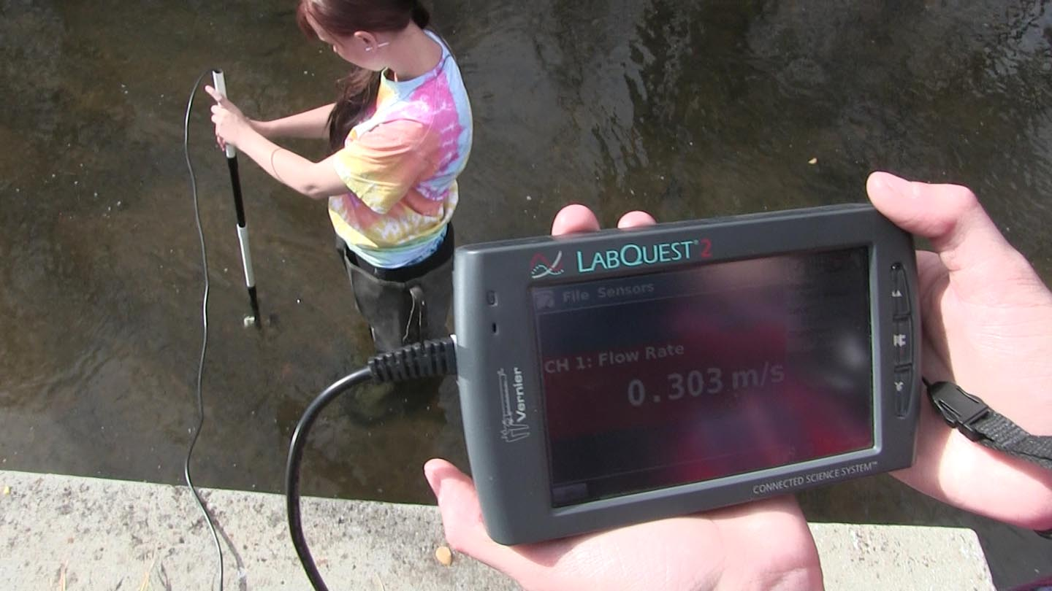
Fig. 7. Cedaredge High School students use Venier sensor to sample Flow Rate. Surface Creek, Cedaredge, Colorado. November 1, 2017.

ADDENDUM B:
Current List of SCAPE Core Team Members and Partner Teachers

Bires, Chris - Science Teacher, Boulder City High School, Boulder City, NV
Bombe, Kaard - Videographer, Phoenix, AZ
Collins, Dan - Professor, Arizona State University, Tempe, AZ (PI)
Cordova, Jesus - Science Teacher, PPEP Tec High School / Jose Yepez Learning Center, Somerton, Arizona
Dunbar, Kevin - Science Teacher, Cedaredge High School, Cedaredge, CO
Elser, Monica - Environmental Educator, ASU / Flathead Lake Biological Station
Lundquist, Laurie – Environmental Artist, Tempe, Arizona
Lybrand, Rex - Science Teacher, Telluride High School, Telluride, Colorado
McClellen, Kristen - Science Teacher, Grand Junction High School, Grand Junction, Colorado
Noble, Deb - Science Teacher, Pinedale High School, Pinedale, WY
Norenberg, Anne - Intern, Arizona State University, Tempe, AZ
Ortiz, Elena – Professor, Phoenix College, Phoenix, AZ
Phelps, Vicki - Environmental Educator, Telluride Institute, Telluride, Colorado
​Romero, Hector - Science Teacher, PPEP Tec HS / Cesar Chavez Learning Center, San Luis, Arizona
Singh, Renu - Teacher & Director, Gifted and Talented Academy, Maryvale HS, Phoenix, AZ
Ylatupa-McWhorter, Shaun - Spatial Database Technologist

Schools and Educational Centers (past & present)
Animas High School, Durango, Colorado
Arizona State University (GIOS, HIDA, SoLS)
Boulder City High School, Boulder City, Nevada
Cedaredge High School, Cedaredge, Colorado
Dine College, Tsaile, Arizona [inactive]
Grand County High School, Moab, Utah
Grand Junction High School, Grand Junction, Colorado
​Kofa High School, Yuma, AZ [withdrawn]
Lake Havasu High School, Lake Havasu City, Arizona
Maryvale High School, Phoenix, Arizona
Navajo Youth Group, Chinle, Arizona [inactive]
Orme School, Mayer, Arizona (SCAPE@Orme Project) [withdrawn]
Pinedale High School, Wyoming
PPEP Tec HS / Cesar Chavez Learning Center, San Luis, Arizona
PPEP Tec High School / Jose Yepez Learning Center, Somerton, Arizona
Telluride High School, Colorado
Telluride Institute, Telluride, Colorado

ADDENDUM C:
Updated Water Quality Test Equipment
Last update: November 8, 2017

WATER QUALITY TEST EQUIPMENT for the SCAPE EPA GRANT

Notes | Description | Unit Price  “wired” | Unit price “wireless”
 | WATER QUALITY WITH VERNIER | 48.00 | 48.00
 | VERNIER LabQuest2 | 329.00 | 329.00
 | STAINLESS TEMP SENSOR | 28.13
 | STAINLESS TEMP SENSOR (Go Direct wireless)* |  | 59.00
 | PH SENSOR (wired) | 79.00
 | PH SENSOR (Go Direct wireless)* |  | 79.00
 | OPTICAL DISSOLVED OXYGEN SENSOR** | 299.00 | 299.00
 | CONDUCTIVITY SENSOR (wired) | 95.00
 | CONDUCTIVITY SENSOR (Go Direct wireless)* |  | 89.00
 | TURBIDITY SENSOR** | 108.64 | 108.64
 | FLOW RATE SENSOR** | 129.00 | 129.00
Wireless link converts standard wired sensors. | Go Wireless Link (includes charging cable) | 89.00 | 89.00
School choice? | One Sensor chosen by school.
 | LABQUEST VIEWER SOFTWARE | 79.00 | 79.00
 | Shipping (pro rata) | 12.90 | 12.90
Total “wired” |  | $1296.67
Total “wireless” |  |  | $1321.54
*Choose either the “wireless” version (which uses Bluetooth) or the “wired” version. Currently, the “Go Direct” wireless does not communicate with the LabQuest2 Interface (PDA)…but it should in coming months. It does connect directly with Labquest Viewer software enabled tablet or laptop.
**Wireless option not yet available

TRADITIONAL WATER QUALITY TEST EQUIPMENT

Hach Scientific Supply
Notes | Description | # of units | Unit Price | Total Price
 | Test Kit, Stream Survey | 1 | 395.00 | 395.00
 | pH paper (pk/5) | 1 | 12.19 | 12.19
Seems high. | Shipping |  | 41.67 | 41.67
HachTotal |  |  | $448.86 | $448.86

MACROINVERTEBRATE COLLECTION KIT

Ben Meadows Scientific Supply
Measurement | Instrument or Material | # of units | Unit Price | Total Price
Water sample collection | 1 cases (24 count) 250 ml plastic bottles. | 1 | 6.37 | 6.37
Aquatic or terrestrial vegetation / Algae collection | Amber Narrow-Mouth Safety- Coated Glass Bottles 24 per case = 140.10 | 1 | 14.01 | 14.01
Aquatic or terrestrial vegetation / Algae collection | Foam-Backed PTFE-Lined Phenolic Caps (12 count) | 1 | 1.96 | 1.90
Safety Equipment | Latex Gloves. 100 per box. | 1 | 8.79 | 8.79
Safety Equipment | Safety Glasses, Uncoated, Clear, 12/Box | 1 | 20.89 | 20.89
Macroinvertebrate collection | Complete Bottom Kick Net - 40in handle, Nitex, 500µm. | 1 | 187.50 | 187.50
Macroinvertebrate collection | Aquatic Invertebrate Lab Kit | 1 | 333.50 | 333.50
 | Sampling Kit contains:
 | •Twelve (12) Small white "critter pickin (TM)" pans (182-F20)
 | •Twelve (12) Forceps (7905-T10)
 | •Sink sieves (184-A15), pack of 6
 | •Plastic vials (7912-P50), 48 count
 | •Twelve (12) Clear plastic rulers (039030) for measuring specimens
 | •Twelve (12) Hand Lenses (78-520)
 | •Teasing needles (7905-T24), pack of 12
 | •Set of comprehensive teacher instructions
•Twelve (12) Insect ID
sheet (039020) with instructions
Ben Meadows Total |  |  |  | $572.96

TOTAL Expenses per Vendor

Vendor Totals | Description |  |  | Total Price
Vernier | Digital Water Quality Test Equipment Equipment (suggested) |  |  | 1400.00
Hach | Traditional Water Quality Test Equipment |  |  | 448.86
Ben Meadows | Macroinvertebrate Collection Kit |  |  | 572.96
Grand TOTAL | Estimated total may vary depending on your choice of Vernier Sensors. Also, Hach equipment NOT necessary for implementation of SCAPE curriculum. For the purposes of budget tracking, reserve at least $2500 in your budget for equipment. |  |  | $2421.82

$344.28 is budgeted for each school to conduct one field trip; Mileage = ~100 miles @ $0.445/mi., meals
@ $12 ea. for 25 students. (Note: actual mileage & meal costs may vary from school to school, but no sub-grant shall exceed the $5,000 limit).

Overhead for each school is budgeted at 10% per the RFP.

For further information, contact Dan Collins (PI), dan.collins@asu.edu / 480-206-2037

