Dan Collins, Principal Investigator
SCAPE
Arizona State University
PO Box 871505
Tempe, AZ 85287-6011

Phone: 480-206-2037
Email: dan.collins@asu.edu

March 31, 2017

Karen Scott
Senior Environmental Education Specialist
US EPA
Office of External Affairs & Environmental Education
1200 Pennsylvania Ave., NW, 1426D
Washington, DC 20460

Phone: 202-564-2194
Email: Scott.Karen@epa.gov

RE: Quarterly Report #3 (Jan. 1, 2017 – March 31, 2017)

Grant Number (FAIN): 83659001
Title: SCAPE (Sustainable Communities and Place-based Education)
Budget Period: 06/01/2016 – 5/31/2018

Dear Karen: This third quarterly report reflects SCAPE EE curriculum development activities over the past three months. Our next report will be delivered on or before June 30, 2017, our one year anniversary.

As I indicated in my last report, our entire curriculum development process is being supported by the new G-Suite (formerly Google Apps) line of tools and cloud-based technologies. You had mentioned some difficulties in accessing the files. Still, you should have access to the entire document through the following link: https://drive.google.com/drive/folders/0B-0ozZ-Ffhtnel90Vm1fVWZHaGs?usp=sharing

The most convenient place to start is with the Table of Contents, which provides links to the entire curriculum: https://docs.google.com/document/d/1Sg1Bw4OTF3_sdd_oxOS6dkBPenowcNMTQ7dIEUKX8LM/edit

For a flavor of what’s been going on in the field, check out this video footage from our documentarian, Kaard Bombe. This is a private video, so you have to enter the password “ORME” (case sensitive) after clicking on this Vimeo link: https://vimeo.com/210998499 . Kaard used a drone to capture the environs of the Orme School in northern Arizona from the air. He then cuts to the lab of master teacher Casey Jones where the students used digital water quality probes to evaluate dissolved oxygen, temperature, and pH in an artificial stream (See images, pp. 4 – 7).

My most immediate collaborators, Elena Ortiz, Monica Elser, and Helen Rowe, continue to generate original course materials and invaluable feedback on the curriculum as a whole. Our master teachers in our two pilot schools and Curriculum Design Team (Lybrand and Jones) are providing responses on the following specific lessons. Versions of these are being implemented in their courses at Orme School and Telluride High School this Spring as indicated previously in earlier reports:

  - Lesson on Environmental History:
https://docs.google.com/document/d/1nSjG4Cpg33Y41z4BK_KNJERE-T4RmUDGw3BJq836u5k/edit
  - Exercise on Map Comparison:
https://docs.google.com/document/d/1i8-_eaU7k1oOktTP4zM-UnzLkS-C1w1VeAnGviMcIYE/edit
  - Lesson on Water Characteristics & Chemistry:
https://docs.google.com/document/d/1QWbs0bn-6b2vGvp-kRB7XmT-Lw77oCDvv2XKsmxtEzM/edit
  - Lesson on Stream Flow:
https://docs.google.com/document/d/1g_aHV0I_1N2Xxq4IMUvR6lTNeSVFn57_58DueCBmdig/edit#
  - Lesson on Macroinvertebrates:
https://docs.google.com/document/d/1sVQkS0LG38VyAMyCzN-z5uJ0T1ZOzLHgG2kpyIYLKzM/edit

We continue to expand on the website for the project: http://coloradoriverscape.org The site features interactive maps, a document repository, a bibliography, links to team members and project partner schools, and a detailed report of our first Curriculum Design workshop. The online map utilizes ArcGIS protocols so layers from existing geospatial information sources can be added to easily accessible Google “My Maps” as needed.

In terms of the map components, we are working on tighter integration with the specific lesson plans and the support materials to make them as relevant as possible to the River as its understood from particular community perspectives. Quite a lot of progress has been made in developing a pipeline for maps that provide orientation to the project as a whole and specific polygons and points defining study areas. Currently we are using a combination of professional ArcGIS mapping tools (ESRI), an ESRI application called ArcGIS online, and Google mapping tools (Google Earth and My Maps). At the level of the individual high schools, teachers and students will be loading their data directly into Google “My Maps.” Here is a working version of the map I provided in the last report: https://www.google.com/maps/d/u/0/viewer?mid=1hDPE0XWEZxogS-Q8koFJhRrpNyM&ll=37.657007152871344%2C-112.10488478125001&z=6

Research into cloud-based technologies for supporting the project and facilitating the sharing of information across our 10 schools is being conducted by project tech guru, Shaun Ylatupa-McWhorter from ASU’s University Technology Office. Shaun is the one who recommended that we work within the new Google “G-Suites” to provide an over-arching framework for the project.

Our project “financial specialist” at ASU is Linda Guerrero who has outlined a set of tasks for keeping on top of expenditures. Linda and I have been meeting regularly to discuss the financial picture.

Our team roster—both from ASU and our partner schools—is shaping up. See the full list here: http://www.coloradoriverscape.org/partners.html Unfortunately, we have not as yet received commitments with the two schools I mentioned in my last report--Shiprock High School, a reservation high school in Northwest New Mexico, and Maryvale High School, part of the Phoenix Union High School District. I need to establish a working relationship with these schools in the coming weeks.

Other logistical challenges include the training of at least one of our high school teachers—Alisha Porosky at Lake Havasu High School—who will not be able to attend the workshop next summer in Colorado. Fortunately, we are able to call on the services of Dr. Paul Haberstroh, who has offered to provide training in his science lab at Mohave Community College in Lake Havasu City, Arizona. You may remember that Paul suffered a stroke just about a year ago and had to recuse himself from the workshop last June in Colorado. However, he is back to teaching now and will be invaluable as a resource specialist situated on the lower Colorado River.

We continue to work closely with the University Office for Educational Evaluation and Effectiveness (UOEEE)—in particular, Matthew Gallagher and Alison Cook-Davis. As their involvement will increase with the start of the second year of the grant, we have developed a detailed calendar for their participation and deliverables (based in the original EPA grant formative and summative targets, but with more detail.). An updated “SCAPE Quarterly Report” for teachers was recently completed by Matthew. It is linked here: http://www.coloradoriverscape.org/info.html

With respect to our second Curriculum Design Workshop and Water Camp (teacher training and roll-out), we have now received commitments from most of the schools to make the trek to Colorado during the week of June 19 – 23, 2017. As indicated previously, June 19 – 18 will be devoted to placing the finishing touches on the curriculum. June 20 – 21 will be in-service training for teachers from our partner schools from Wyoming, Utah, Nevada, Colorado, and Arizona.

In addition to the video documentation completed since last June, our videographer, Kaard Bombe, will be covering the June 2017 workshop and traveling to most of the project schools during the 2017-2018 academic year. The final report will feature a video overview that not only captures the work being done on site with our partner schools, but vignettes of team members discussing their hopes for the project (during the curriculum development phase) as well as their reflections on the successes—and failures—at the conclusion of the project. Last month, Kaard and I joined forces to conduct a formal interview with our newest team member, Dr. Elena Ortiz, to capture her aspirations and thoughts about the project.

Much time was spent on satisfying ASU’s Institutional Review Board (IRB) requirements for developing a Human Subjects protocol. I have posted the entire document here: http://www.coloradoriverscape.org/info.html

Scroll down for screen grabs from Kaard’s video, a list of milestones, and talking points for formative evaluation.

Please advise if you need further documentation of our efforts to date.

Regards,

Dan

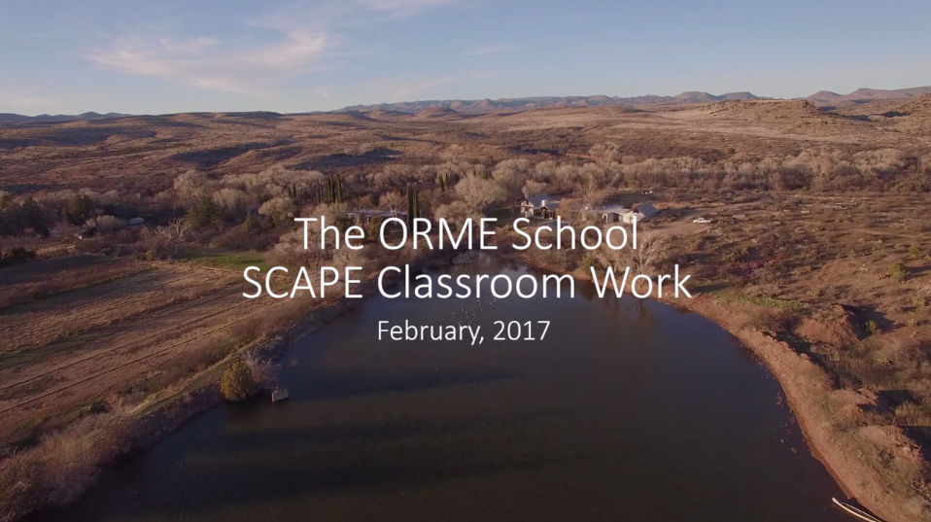
Fig. 1. SCAPE videographer Kaard Bombe traveled to the Orme School in Northern Arizona to document current work with master teacher, Casey Jones, and his students. The image above was captured from a GoPro camera attached to a drone in February 2017.

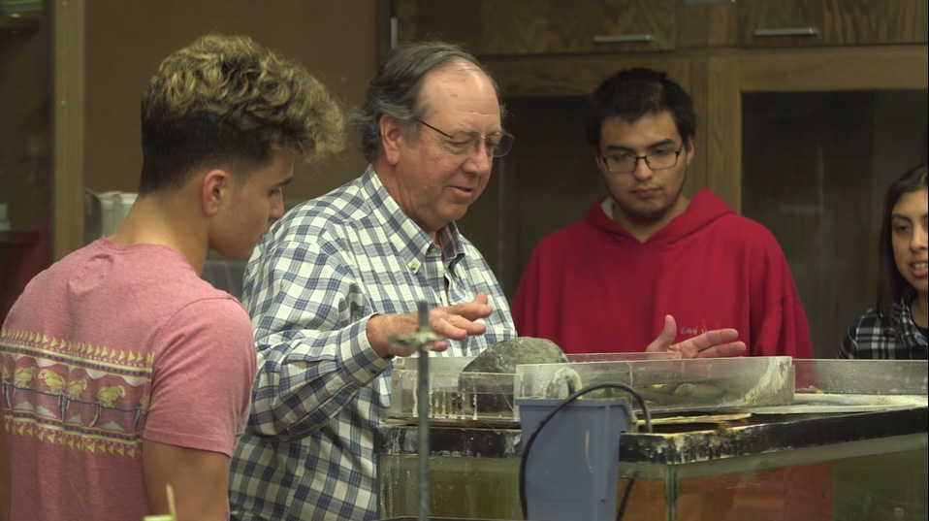
Fig. 2. Casey Jones introduces his students to water quality testing processes using an artificial stream in his lab at the Orme School (February 2017).

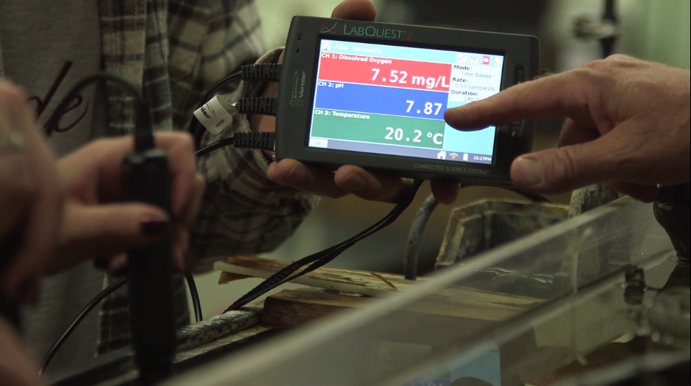
Fig. 3. Detail shows LabQuest handheld computer developed by Vernier. The unit provides real-time data from various digital probes used to capture water quality parameters. This system is being used by students in the field to test water quality at various collection sites up and down the Colorado River for the SCAPE project (February 2017).

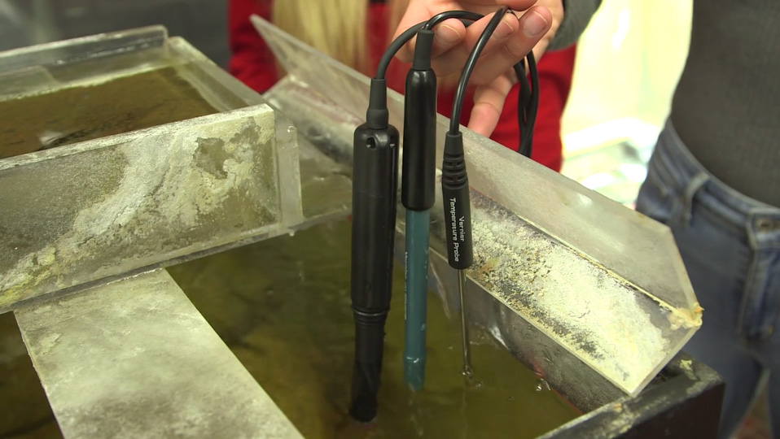
Fig. 4. Detail shows the digital probes used for measuring temperature, dissolved oxygen, and pH in an artificial stream at the Orme School (February 2017).
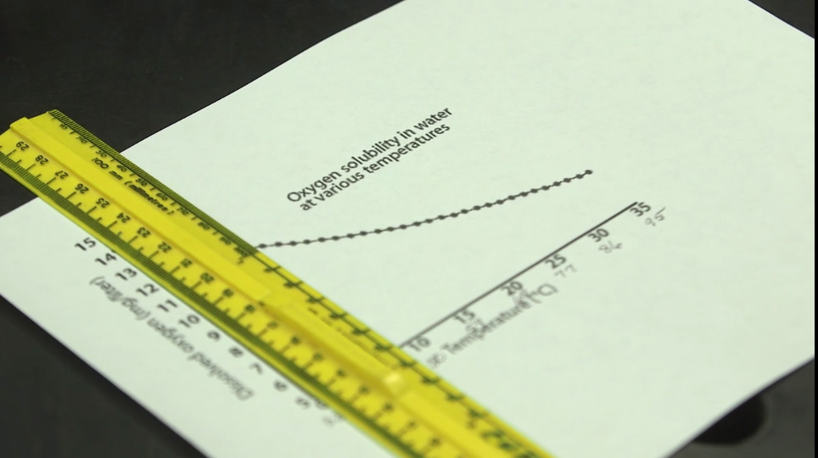
Fig. 5. Graph of Oxygen solubility used by Casey Jones at the Orme School (February 2017).

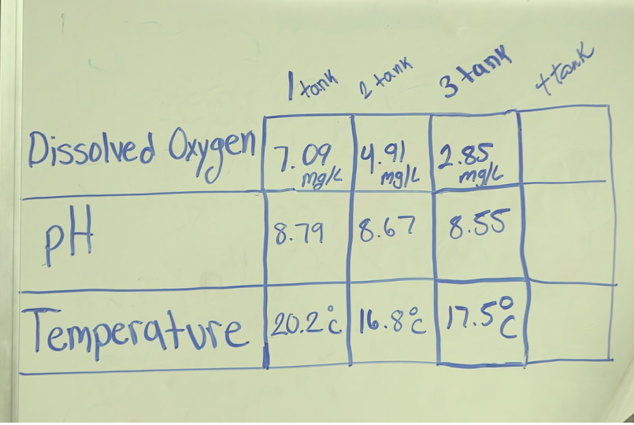
Fig. 6. Tabulation of data derived from Vernier digital probes at the Orme School (February 2017).

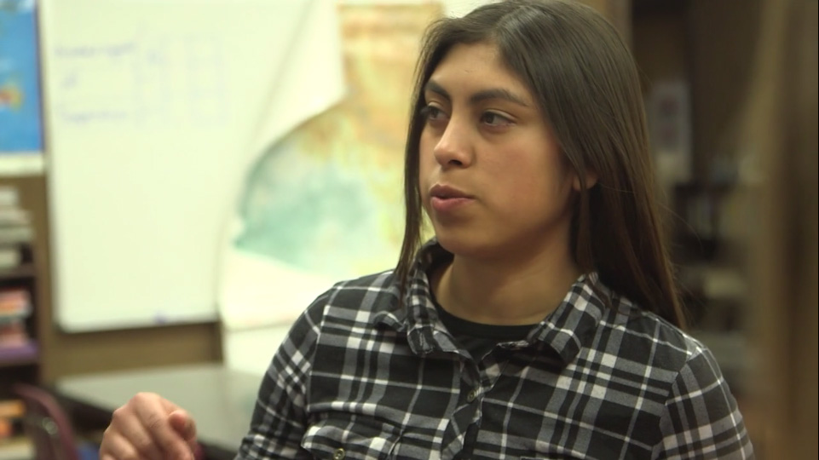
Fig. 7. “So, one of the reasons when you see fish belly up (could be due to lack of dissolved oxygen in the water)?”

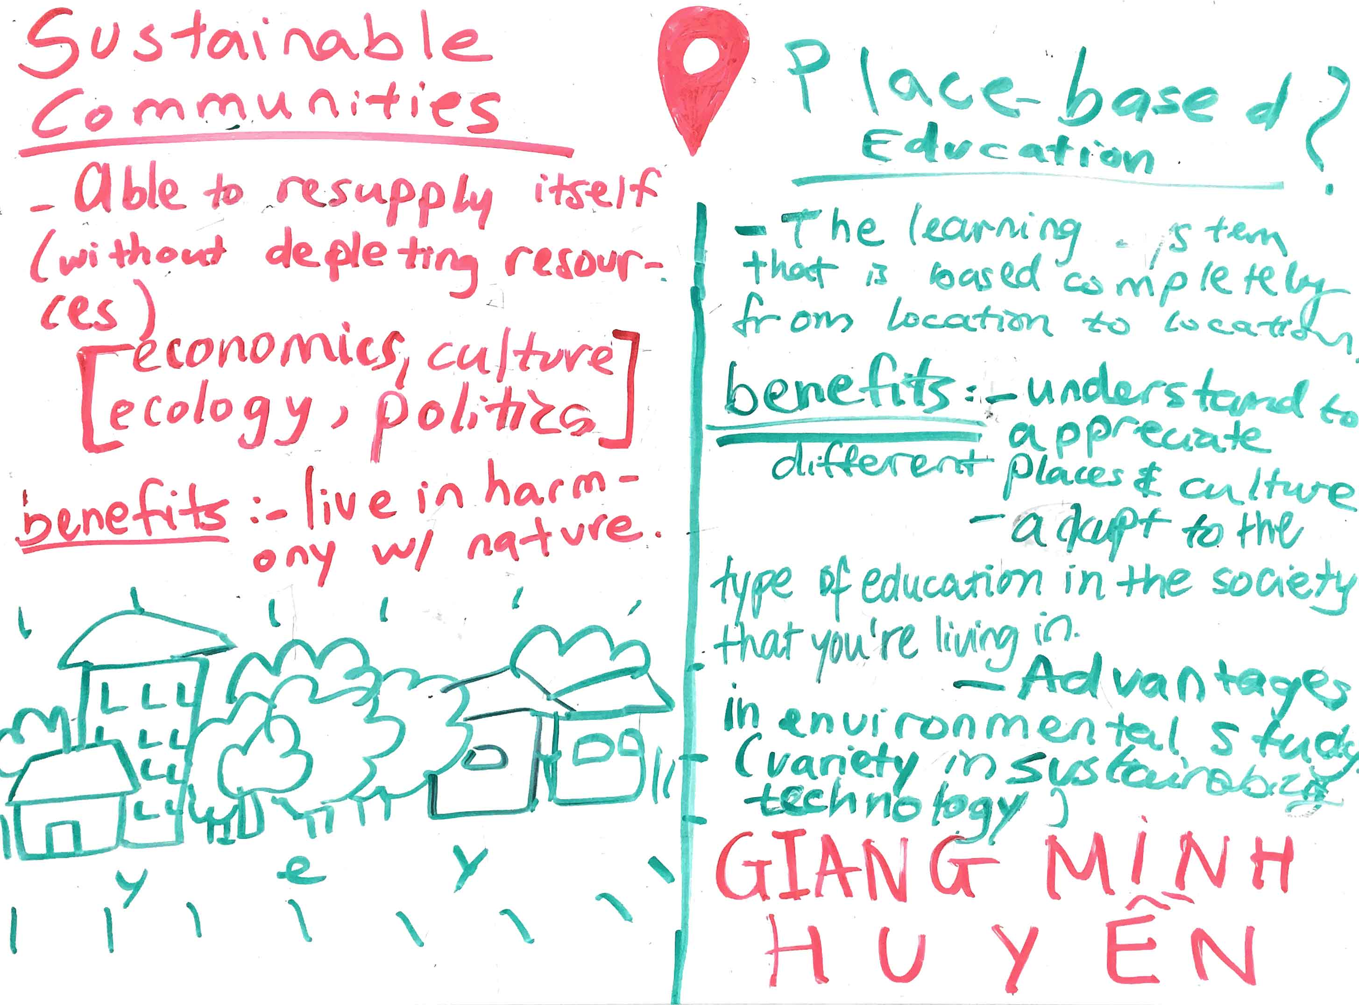
Fig. 8. One Orme School student’s responses to the prompts “What is a Sustainable Community” and “What are the benefits of a Place-based Education?” (photo: Kaard Bombe, 2017).

ADDENDA
Milestones
June 24 – 26, 2016. Curriculum Design Workshop, Telluride, CO
Aug. 17, 2016. Conference call. University Office of Evaluation and Educational Effectiveness (UOEEE).
Sept. 1, 2016. FTF meeting with Nikol Grant, Fiscal Supervisor and Linda Guerrero, Fiscal Specialist, GIOS
Sept. 12, 2016. Conference call. University Office of Evaluation and Educational Effectiveness (UOEEE)
Oct. 29, 2016. First quarterly report submitted to Karen Scott at the EPA.
Nov. 2, 2016. FTF meeting with Linda Guerrero, Fiscal Specialist, GIOS
November 11-12, 2016. Visit to the Orme School. Participated in Sustainability Institute. Reviewed Test equipment with Casey Jones.
Nov. 30, 2016. FTF meeting with Linda Guerrero, Fiscal Specialist, GIOS
Dec. 2, 2016. FTF meeting with Monica Elser and Elena Ortiz at GIOS.
Dec. 14, 2016. FTF meeting with Linda Guerrero, Fiscal Specialist, GIOS
Dec. 16, 2016. SKYPE call with 7 team members.
Dec. 23, 2016. Conference call with Shaun Ylatupa-McWhorter, computer specialist
Dec. 27, 2016. Conference call with Casey Jones, Science teacher, Orme School
Dec. 31, 2017. Second quarterly report submitted to Karen Scott at the EPA.
January 5, 2017. Curriculum Design meeting with Elena Ortiz and Monica Elser
January 31, 2017. FTF meeting with Linda Guerrero, Fiscal Specialist, GIOS
February 23, 2017. FTF meeting with Linda Guerrero, Fiscal Specialist, GIOS
Feb. 27, 2017. Kaard travels to Orme School to document Casey Jones and students.
Feb. 28, 2017. Video interview with Elena Ortiz at Phoenix College (Dan & Kaard).
March 15, 2017. Meeting with Evaluation specialists Matthew Gallagher & Alison Cook-Davis at UOEEE.
March 27, 2017. IRB protocols approved.
March 30, 2017. FTF meeting with Linda Guerrero, Fiscal Specialist, GIOS
March 31, 2017. Third quarterly report submitted to Karen Scott at the EPA.

Questions and Talking Points for Formative Evaluation

- Master teachers. Do our two master teachers, Rex Lybrand (Telluride) and Casey Jones (Orme), have the resources they need (both in terms of curriculum and equipment) to test out components of the curriculum in their respective schools this Spring?

- Articulation. To what degree does the SCAPE project mission (https://docs.google.com/document/d/1qKv2W76C-8hpEZMfG2CE0d9Hwdr05D5rNYXtHLJAiT0/edit) align with the mission of particular high school science programs?

- Website. Any suggestions regarding our website? Access it here: http://coloradoriverscape.org Would anyone be interested in sharing administrative duties? How can we make it better? Does it have the tools we need to support the range of functions we are proposing?

- Google Docs. Hopefully everyone is comfortable with using Google Docs to access and provide editorial comments/changes to the online SCAPE curriculum found here (direct link to Table of Contents): https://docs.google.com/document/d/1Sg1Bw4OTF3_sdd_oxOS6dkBPenowcNMTQ7dIEUKX8LM/edit Google docs has proved to be a great way to collectively develop the curriculum. Our plan is to continue using it as a development tool. As particular lessons are finished, they can be exported as .pdf documents that can be linked to the project website.

- Cloud technology. Monica, Elena, and I all agree that we are better off using existing “off the shelf” products for curriculum development and sharing (viz., Google products). This means the “back-end” is covered. What we need on the “front end” is something that is “unique” and “unified.” We also feel that it would be a mistake to simply “partner” with a larger established project such as Globe.org. We’re looking for a kind of dashboard to all of the different components of the program—both for access (at different levels of authority) and for active participation in terms of uploading documents, analysis, and comparison of data.

- School Participation. LOC letters (letters of commitment) from principals needed (but we have letters in hand from Orme and Telluride). Business manager connection for facilitating equipment purchases is needed.

- Suggestions for inclusions in second quarterly report to the EPA (due end of December 2016). My first report can be accessed here: http://www.coloradoriverscape.org/uploads/2/0/1/2/20120621/epa_quarterlyreport1_final_20161029.pdf

Master Teachers. We continue to follow the proposed timeline for evaluation from our original grant application. See Table 1 on pages 9 – 10 of grant proposal (attached). We indicated that our two pilot teachers, Casey Jones at the Orme School in Arizona and Rex Lybrand at the Telluride High School in Colorado would provide feedback concerning the curriculum. The both participated in the initial workshop and numerous phone calls and face to face sessions over the past three months.

Both teachers are planning on introducing components of the curriculum in their Spring 2017 classes. Casey in particular will be utilizing the SCAPE materials in his Environmental Science (what level??) class at the Orme School; Rex will be introducing the curriculum to his AP Environmental Science class

From the initial grant proposal:

Formative Feedback to Development Team from Master Teachers
Four Skype conference calls, spaced every two months (Oct. Dec. Feb. April) between master teachers and development team. Adjustments to online materials can be made remotely. Development team will seek feedback from both teachers and students via SCAPE interface and related emails, tweets, and blog postings.
Evaluation: Selective evidence of student and teacher engagement and collaboration via SCAPE. Evidence of increased knowledge, including from vocabulary and details of posts, and skills in content areas, including local and systemic environmental policies and practices, water quality, and environmental science. Coding of online feedback provides grounded method (Strauss, 1987; Charmez et al, 2001) for capturing key constructs, common themes, technical issues, and novel outputs.
In addition to the methods listed above for gathering evidence, Matthew Gallagher…

Meetings.

We have held several face to face meetings and Skype calls over the past three months. Most notably, a Skype call involving seven individuals--five educators, an evaluator, and a computer specialist--was conducted on Dec. 16, 2016. The call included Dan Collins, Monica Elser, Elena Ortiz, Helen Rowe, Matt Gallagher, Shaun Ylatupa-McWhorter, and Casey Jones. The call was organized using the following questions:

- How do the goals of the SCAPE curriculum align with the mission/goals of individual schools?
- How does this resonate with our p
- To what degree can we utilize “off the shelf” software solutions (e.g., Google products) to build a robust and accessible system to meet the goals of the project?
- Are the methods required by EPA and ASU for invoicing for equipment, staffing, and programming acceptable to our partner schools? Or does this place an undo burden on schools with limited resources?
- How will the pilot curriculum be implemented in the Spring 2017 in our pilot schools.

Equipment.

Curricular elements.

Maps.
Pre-field work goals.
Local resources integrated into curriculum (e.g., Casey’s .pdfs about Agua Fria watershed)
Website.
Google Drive and curriculum development.

ADDITIONAL PROJECT DETAIL

SAMPLE LESSONS for Orme and Telluride (each of these needs work…but hopefully you’ll get the idea. We hope to have each of these Lessons—or similar--completed by January 1):

Lesson on Environmental History: https://docs.google.com/document/d/1nSjG4Cpg33Y41z4BK_KNJERE-T4RmUDGw3BJq836u5k/edit (Needs to be customized for each school region).
Exercise on Map Comparison: https://docs.google.com/document/d/1i8-_eaU7k1oOktTP4zM-UnzLkS-C1w1VeAnGviMcIYE/edit
Lesson on Observation: https://docs.google.com/document/d/1Tr3boWDhRjqnD0c3Cl5tc9H3iq9O_TSaNpUGFCAHJNQ/edit
Lesson on Water Characteristics & Chemistry: https://docs.google.com/document/d/1QWbs0bn-6b2vGvp-kRB7XmT-Lw77oCDvv2XKsmxtEzM/edit
Lesson on Stream Flow: https://docs.google.com/document/d/1g_aHV0I_1N2Xxq4IMUvR6lTNeSVFn57_58DueCBmdig/edit#heading=h.dvr004x91vl9
Lesson on Macroinvertebrates: https://docs.google.com/document/d/1sVQkS0LG38VyAMyCzN-z5uJ0T1ZOzLHgG2kpyIYLKzM/edit
Final Project -- System-Wide Impacts: https://docs.google.com/document/d/1jQNiMkzjDyU5v7oWaZIAzrr6QymhnpfG8WC5phVbgOY/edit

FUSION TABLES > GOOGLE MAPS

In terms of the discussion of visualizing geospatial data, take a look at this YouTube on using Google Fusion tables for visualizing weather data. https://www.youtube.com/watch?v=ok7gz4nAnFE

There is also the tutorial on Fusion Tables > Google Maps here that Monica mentioned: https://support.google.com/fusiontables/answer/2527132?hl=en (mapping distribution of moths)

GOOGLE MAPS versus MY MAPS versus ARCGIS

I have also played around with Google “My Maps” (slightly different than Google Maps) for mapping particular school research sites and linking data. (If you are interested in the distinction, see this site: http://www.gearthblog.com/blog/archives/2014/10/google-my-maps-vs-google-maps.html).

I have created a custom map of the entire study region (CR basin) with partner schools (in progress). Note that I have created a different list for “study areas” and different geographic features of the CR basin. Click on the link below and it’ll take you to a “study area” at Parker Dam (base of Lake Havasu). Click on the blue marker below the dam and you’ll see water samples from USGS (just another test of links and stuff).

https://www.google.com/maps/d/viewer?mid=17f2F8JQCw3VvPMYInalmdwwTEzc

The point of the exercise is to investigate potential tools that are free, easy to access, and provide some essential functionality such as drawing polygons and sharing custom maps. Google’s “My Maps” is quite a bit more user friendly than trying to do this in ESRI ArcGIS products (even versions such as ArcGIS online). Nevertheless, the map I created that is linked to the website was done in ArcGIS. If you zoom to the pushpin at Lake Havasu on the main SCAPE Map and click on it, you will get a little pop-up with a link to sample data located on a My Map site.

PROJECT MANAGEMENT VIA GOOGLE SITES

Shaun suggested Google Sites for providing an over-arching umbrella for the whole project. He will be exploring details such as how to control access for different user groups (developers, teachers, students, etc.). Information about Google Sites can be found here: https://support.google.com/groups/answer/46601?hl=en

SCAPE WEBSITE

For the time being, we are sticking with Weebly for developing our website. I have linked the Orme School – to a new page called “SCAPE@ORME” – in two places: as a link to the pop up on the main map and in the Partners List. Whether or not this is the best “portal” to the activities at each school remains to be seen.

